**AI-Powered Smart Shopping Assistant**

P1A1

**Problem statement:**

Shoppers often struggle with finding the best deals, choosing the right products, and staying within budget. Many online platforms offer discounts, but comparing them manually is time-consuming and inefficient. Additionally, some customers need personalized recommendations based on their preferences, previous purchases, and shopping habits.

The main idea in solving this problem is to create a filter for the customer's preferences through which he can determine the limit he is allowed to spend when purchasing necessities by integrating artificial intelligence into the application or purchase page.

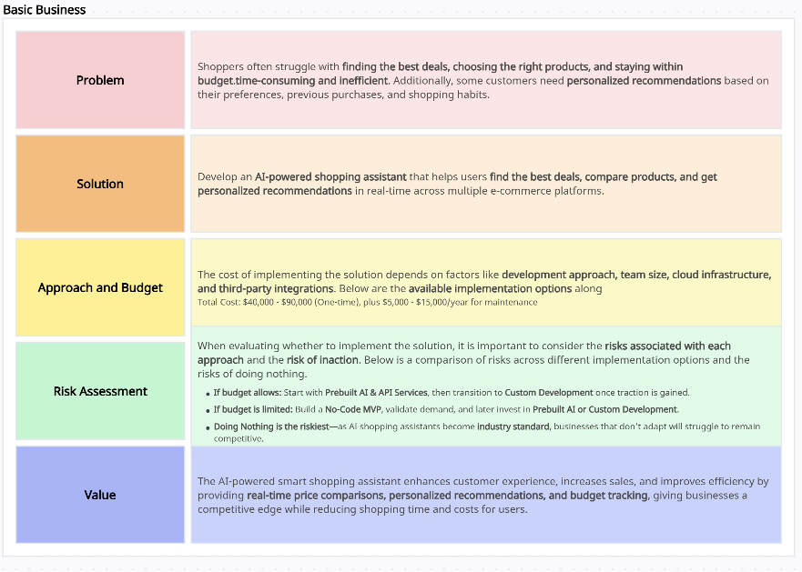**Business case:**

**Scope:**

The scope of the AI-powered smart shopping assistant includes developing a platform that integrates with multiple e-commerce websites to offer real-time price comparisons, personalized product recommendations, and budget tracking. It will support features like deal alerts, voice assistant compatibility, and sustainability ratings. The solution will be available as a mobile app and web platform, providing users with a seamless and efficient shopping experience while helping businesses increase customer retention and sales.

**Goals:**

The goals of the AI-powered smart shopping assistant are:

1. **Enhance User Experience:** Provide a seamless, personalized shopping experience through real-time price comparisons, recommendations, and budget management.
2. **Increase Customer Engagement:** Retain users by offering timely deal alerts, product suggestions, and a user-friendly interface.
3. **Boost Sales for Retailers:** Help businesses drive more sales by connecting customers with the best deals and relevant products.
4. **Reduce Shopping Time and Effort:** Enable shoppers to find the best offers and make informed decisions faster, reducing the time spent searching.
5. **Promote Sustainability:** Offer eco-friendly product recommendations, promoting responsible shopping habits.
6. **Enable Data Insights:** Collect data on customer preferences and behavior to improve recommendations and marketing strategies.